**Faculty of Computer Science and Information Technology**

**University Malaya**

**Semester 1, 2016/2017 Academic Session**

**WIX2002 Project Management**

**____________________________________________________________________________**

**Tutorial 3**

1. How does the WBS differ from the project network?
2. Why is slack important to the project manager?
3. Draw a project network from the following information. What activity is a burst activity (s)? What activity is a merge activity(s)?

|  |  |  |
| --- | --- | --- |
| ID | Description | Predecessor |
| A | Identify Topic | None |
| B | Research Topic | A |
| C | Draft paper | B |
| D | Edit paper | C |
| E | Create Graphics | C |
| F | References | C |
| G | Final Draft | D, E, F |

1. You have signed a contract to build a garage for UM. You will receive a RM500 bonus for completing the project within 15 working days. The contract also contains a penalty clause in which you will lose RM100 for each day the project takes longer than 15 working days.

Draw a project network given the information below. Complete the forward and backward pass, compute the activity slack, and identify the critical path. Do you expect to receive a bonus or a penalty on this project?

|  |  |  |  |
| --- | --- | --- | --- |
| ID | Description | Predecessor | Time  (days) |
| A | Pour foundation | None | 3 |
| B | Erect frame | A | 4 |
| C | Roof | B | 4 |
| D | Windows | B | 1 |
| E | Doors | B | 1 |
| F | Electrical | B | 3 |
| G | Rough-in-frame | C, D, E, F | 2 |
| H | Door opener | E,F | 1 |
| I | Paint | G, H | 2 |
| J | Cleanup | I | 1 |

5. Project risks can/cannot be eliminated if the project is carefully planned. Explain.

6. What is the difference between avoiding a risk and accepting a risk?

7. What is the difference between mitigating a risk and contingency planning?

8. Given the predecessors and activity times below (Table 1), calculate the average duration for each activity. Prepare a project network using AON; compute the early, late, and slack activity times. Identify the critical path. What is the expected project duration? Based on the Z values given in Table 2, what are the probabilities of completing the project by the 26th day and 38th day?

Table 1: Project Network Information

|  |  |  |  |  |
| --- | --- | --- | --- | --- |
| **ID** | **Predecessor** | **Optimistic** | **Most Likely** | **Pessimistic** |
| A | None | 3 | 6 | 9 |
| B | None | 2 | 4 | 8 |
| C | A | 2 | 3 | 9 |
| D | A | 5 | 9 | 12 |
| E | B | 6 | 8 | 10 |
| F | C | 1 | 5 | 9 |
| G | D, E | 4 | 12 | 16 |
| H | F, G | 2 | 6 | 14 |

Table 2: Z Value

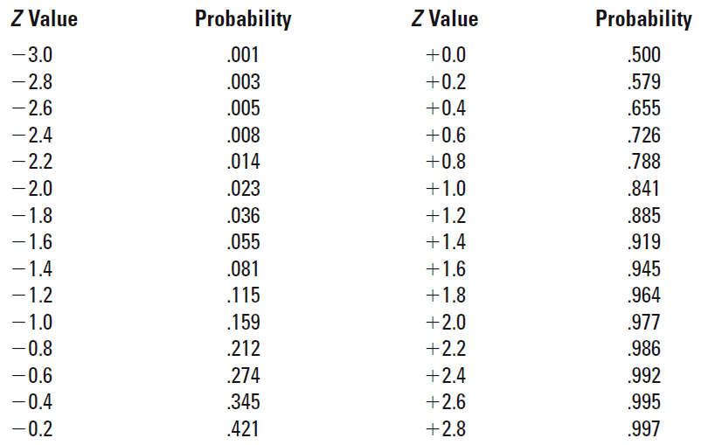

9. Explain the difference between budget reserves and management reserves.

10. What are the likely outcomes if a change control process is not used? Why?